Contents

1. GITHUB desktop INSTALLATION STEPS 2

1. Download link 2

2. Initial installation settings 2

3. Providing necessary data 3

4. Finishing installation 3

# GITHUB desktop INSTALLATION STEPS

## Download link

<https://desktop.github.com/>

## Initial installation settings

If you already have a GitHub account, skip this step. Otherwise, if you would like to create one, click on “Create your free account”.



Figure 1 - Initial installation settings

## Providing necessary data

Fill in requested data (name and email).

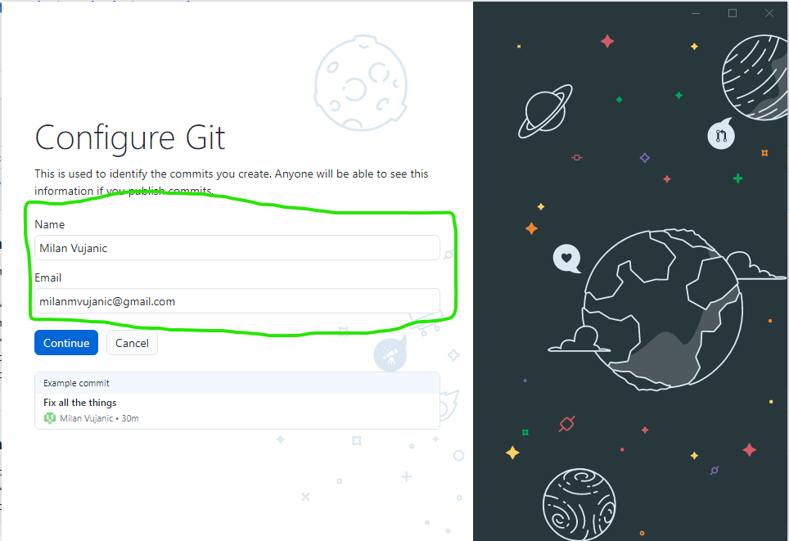

Figure 2 - Providing necessary data

## Finishing installation

Uncheck highlighted suggestion and click “Finish”

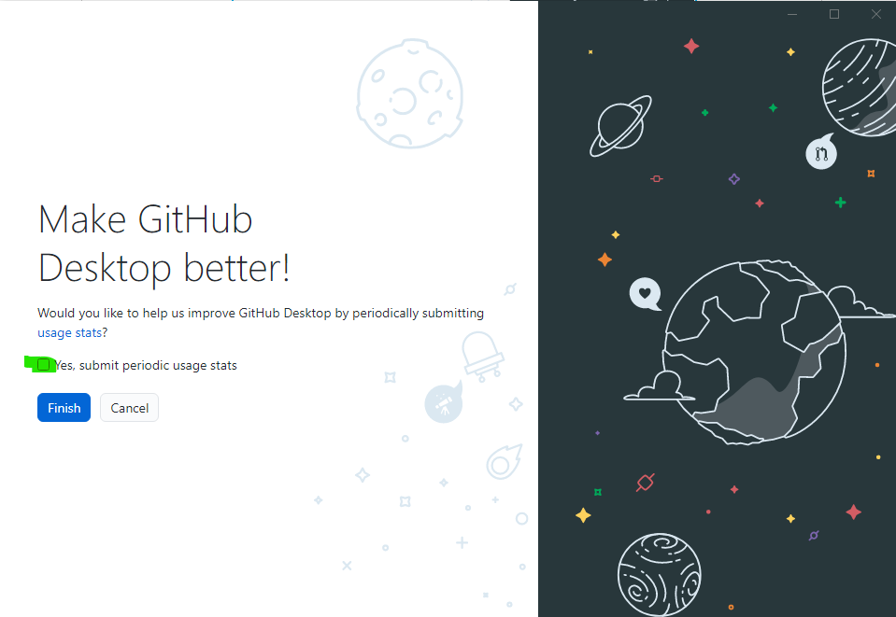

Figure 3 - Finishing installation